PRACTICE 4

Search:

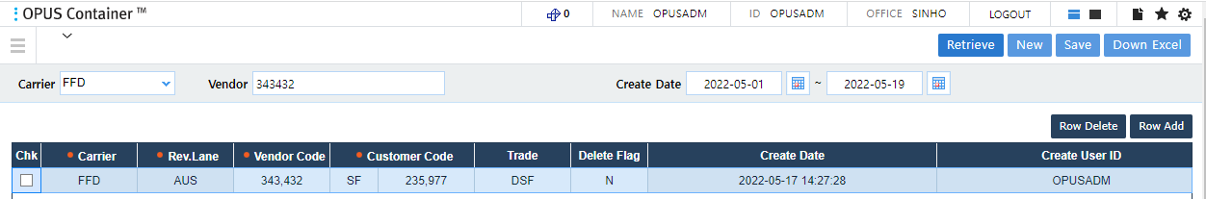

New:



Down Excel:

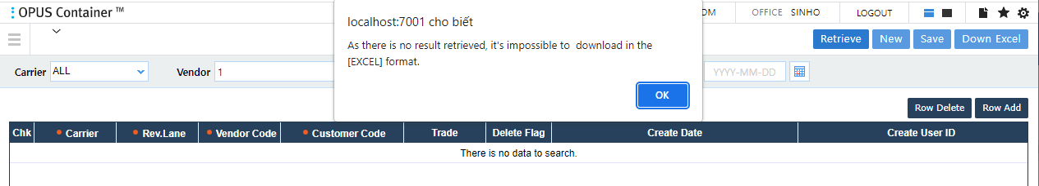

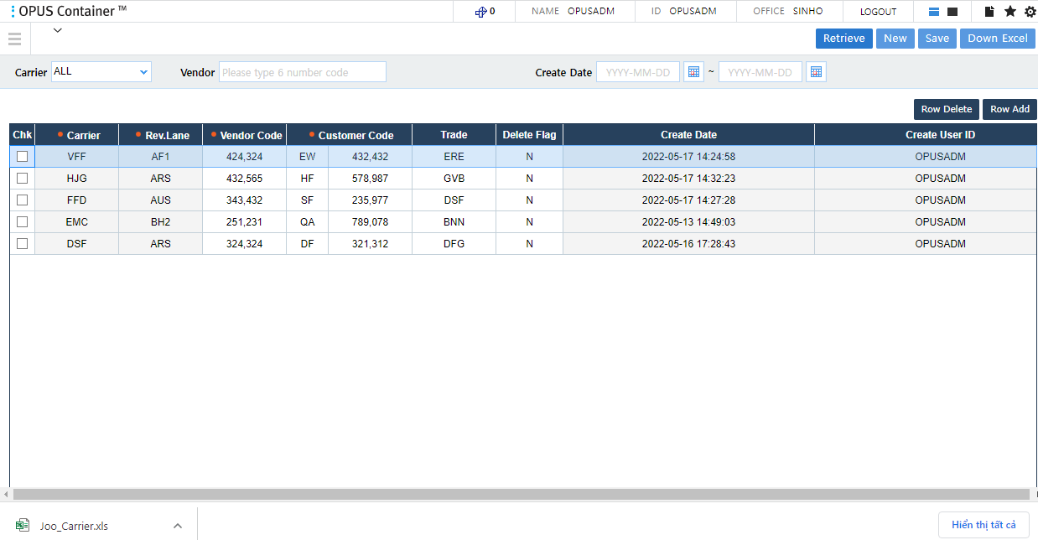

Row Add:

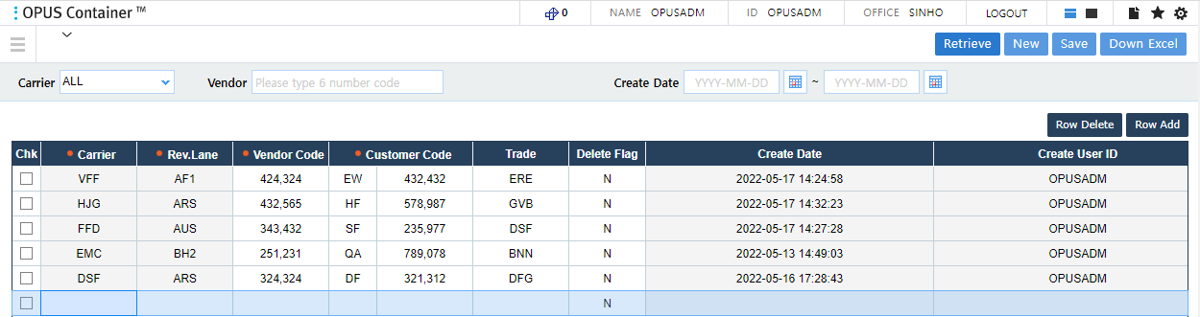

Row Delete:

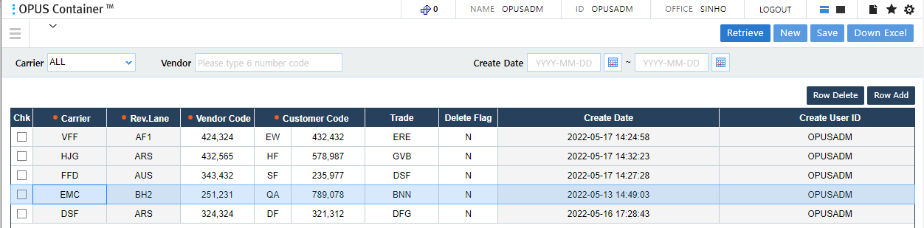

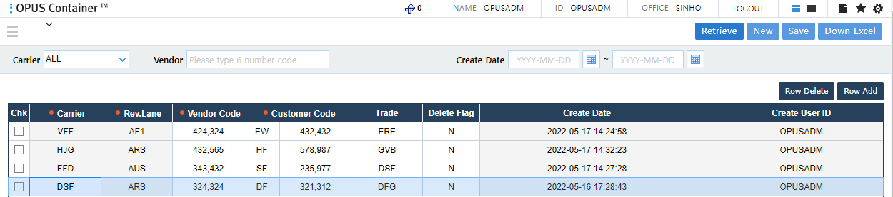

Save:

+ Nothing changes:

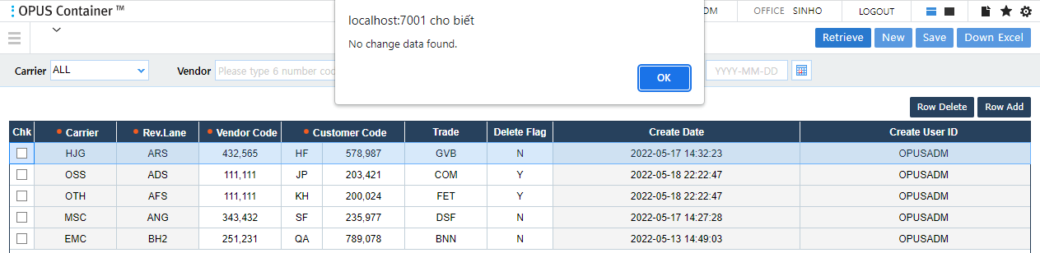

+ Insert:

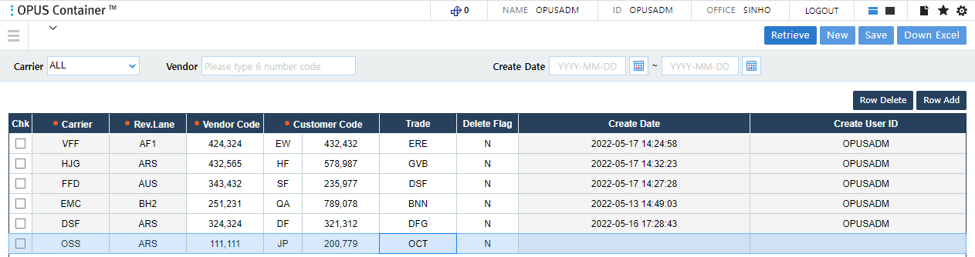

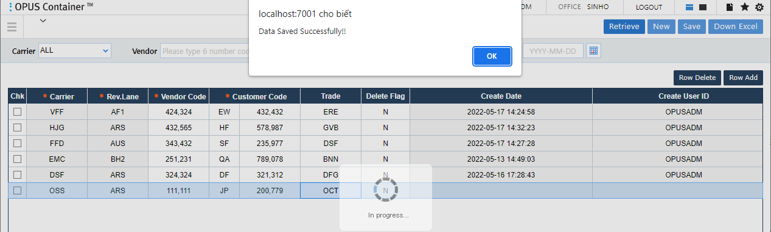

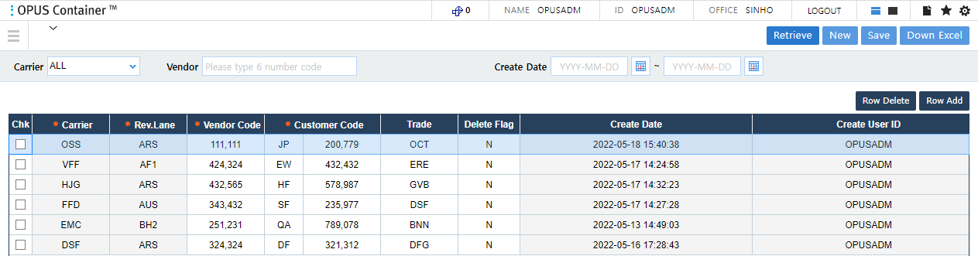

+ Update:

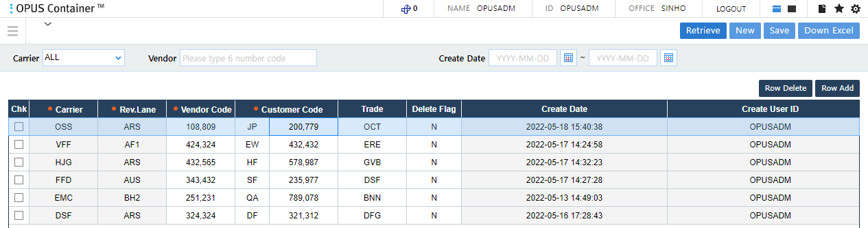

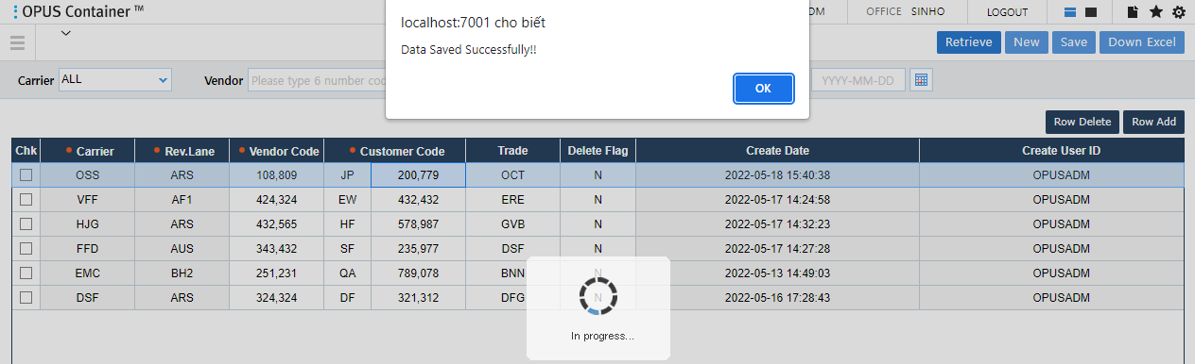

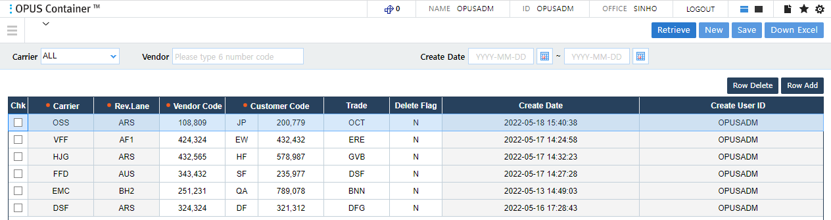

+ Delete:

